Important: RapidSnapshot requires a display in order to run.

Related files :
1) argument_linux.xml
2) start_snapshot_auto.sh
3) start_snapshot_auto_multi.py

Step :
- Start RapidSnapshot normally using the desktop icon.

- Create your connection via the User Interface and note down the connection name.
- Optional: create a template from the User Interface and note down the template name.
- Optional : Support User Management, if you would like to run RapidSnapshot with your specified user
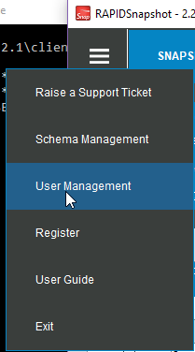
a. Select menu 'User Management'
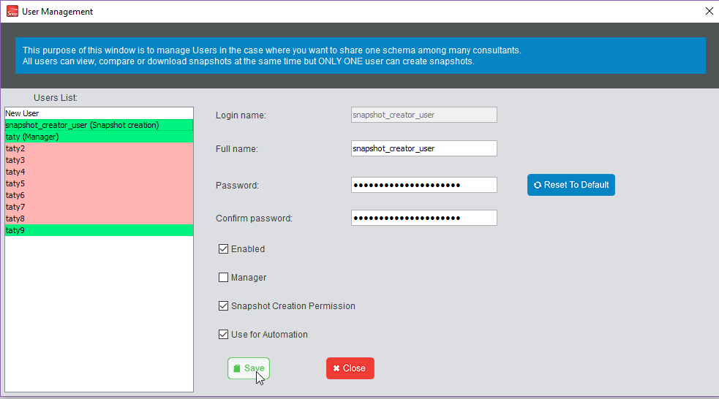
b. If you would like to create new user or edit any user in a list and use it for the automation, check 'Use for Automation' and 'Snapshot Creation Permission' and click 'Save'

- Modify the argument_linux.xml file
a. Populate the <connectionName> with the information from 2.
b. Specify <templateSelectionName> (let <templateSelectionName> blank if you skipped 3.)
c. Change <logFolderPath> to be a full path in your Linux system and make sure your folder exists in the system.

- Check if the file start_snapshot_auto.sh exists in this path /opt/res/homes/res/scripts if not, you can copy from your installed RapidSnapshot folder to that folder.
- Since we need a display in order to run the job, edit start_snapshot_auto.sh and specify your display number.
export DISPLAY=:<YOUR DISPLAY NUMBER>
Example : export DISPLAY=:1
- Run the command from Terminal in your Linux system
a) type crontab -e
b) put the command to create Crontab script for the scheduling job.
<minute hour day-of-month month day-of-week
> /opt/res/homes/res/scripts/start_snapshot_auto.sh <YOUR argument_linux.xml FILE PATH>
b) Press Esc and type :wq to save your scheduling job and exit.
Example : if your argument_linux.xml file path is /home/shared/shared_folder/uploads/snapshot/argument_linux.xml and you want to run RapidSnapshot every 30 minutes, hence your command will be
*/30 * * * * /opt/res/homes/res/scripts/start_snapshot_auto.sh /home/shared/shared_folder/uploads/snapshot/argument_linux.xml

If you want to run RapidSnapshot on every Monday, 17.30, your command will be
30 17 * * 1 /opt/res/homes/res/scripts/start_snapshot_auto.sh /home/shared/shared_folder/uploads/snapshot/argument_linux.xml

Note : the day-of-week goes from 0-6 where 0 is Sunday or you can check the command in this site https://crontab.guru

